**LAB TASK # 11**

FORM 1 :

using System;

using System.Collections.Generic;

using System.ComponentModel;

using System.Data;

using System.Drawing;

using System.Linq;

using System.Text;

using System.Threading.Tasks;

using System.Windows.Forms;

using System.Data.OleDb;

namespace lab12

{

public partial class Form1 : Form

{

public Form1()

{

InitializeComponent();

}

OleDbConnection con = new OleDbConnection(@"Provider = Microsoft.Jet.OLEDB.4.0; Data Source = C:\SAAD KHAN\Database7.mdb");

OleDbDataAdapter adap = new OleDbDataAdapter("select* from bank", @"Provider = Microsoft.Jet.OLEDB.4.0; Data Source = C:\SAAD KHAN\Database7.mdb");

DataSet d1 = new DataSet("bank");

int counter = 0;

private void button6_Click(object sender, EventArgs e)

{

textBox1.Text = "";

textBox4.Text = "";

comboBox1.Text = "";

textBox2.Text = "";

}

private void Form1_Load(object sender, EventArgs e)

{

this.bankTableAdapter.Fill(this.database3DataSet.bank);

con.Open();

adap.Fill(d1, "bank");

if (d1.Tables["bank"].Rows[0]["AccountType"].ToString() == "saving")

{

checkBox1.Checked=true;

}

else

{

checkBox2.Checked = true;

}

}

private void button1_Click(object sender, EventArgs e)

{

if (counter < d1.Tables["bank"].Rows.Count - 1)

{

counter = counter + 1;

textBox1.Text = d1.Tables["bank"].Rows[counter]["AccountNo"].ToString();

textBox2.Text = d1.Tables["bank"].Rows[counter]["Name"].ToString();

textBox4.Text = d1.Tables["bank"].Rows[counter]["Balance"].ToString();

comboBox1.Text = d1.Tables["bank"].Rows[counter]["Branch"].ToString();

}

else if(counter <= d1.Tables["bank"].Rows.Count - 1)

{

MessageBox.Show("You are already on last record");

}

}

private void button2_Click(object sender, EventArgs e)

{

if (counter > 0)

{

counter = counter - 1;

textBox1.Text = d1.Tables["bank"].Rows[counter]["AccountNo"].ToString();

textBox2.Text = d1.Tables["bank"].Rows[counter]["Name"].ToString();

textBox4.Text = d1.Tables["bank"].Rows[counter]["Balance"].ToString();

comboBox1.Text = d1.Tables["bank"].Rows[counter]["Branch"].ToString();

}

else if(counter == 0)

{

MessageBox.Show("You are already on the first record");

}

}

private void button4_Click(object sender, EventArgs e)

{

OleDbCommand com = new OleDbCommand("Update bank set Balance='" + textBox4.Text + "' where AccountNo=@AccountNo", con);

com.Parameters.Add("AccountNo", OleDbType.Integer).Value = textBox1.Text;

com.ExecuteNonQuery();

MessageBox.Show(" One record has been updated");

}

private void button5_Click(object sender, EventArgs e)

{

this.Hide();

}

private void button3_Click(object sender, EventArgs e)

{

OleDbCommand com1 = new OleDbCommand("Insert into bank(AccountNo,Name, BranchCode, Balance) values('" + textBox1.Text + "','" + textBox2.Text + "','" + comboBox1.Text + "','" + textBox4.Text + "')", con);

com1.ExecuteNonQuery();

MessageBox.Show(" One record has been added");

}

}

}

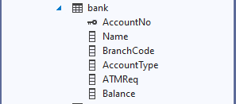

FORM 1 :

using System;

using System.Collections.Generic;

using System.ComponentModel;

using System.Data;

using System.Drawing;

using System.Linq;

using System.Text;

using System.Threading.Tasks;

using System.Windows.Forms;

using System.Data.OleDb;

namespace Lab12_1

{

public partial class Form1 : Form

{

public Form1()

{

InitializeComponent();

}

OleDbConnection con = new OleDbConnection(@"Provider = Microsoft.Jet.OLEDB.4.0; Data Source = C:\SAAD KHAN\Database7.mdb ");

private void button4_Click(object sender, EventArgs e)

{

OleDbDataAdapter adap = new OleDbDataAdapter("select* from student", @"Provider = Microsoft.Jet.OLEDB.4.0; Data Source = C:\SAAD KHAN\Database7.mdb ");

DataSet d1 = new DataSet("student");

MessageBox.Show("Connection built");

adap.Fill(d1);

dataGrid1.DataSource = d1;

}

private void button2_Click(object sender, EventArgs e)

{

Form3 f3 = new Form3();

f3.Show();

}

private void button1_Click(object sender, EventArgs e)

{

Form2 f2 = new Form2();

f2.Show();

}

private void button5_Click(object sender, EventArgs e)

{

Form4 f4 = new Form4();

f4.Show();

}

private void button3_Click(object sender, EventArgs e)

{

Form5 f5 = new Form5();

f5.Show();

}

}

}

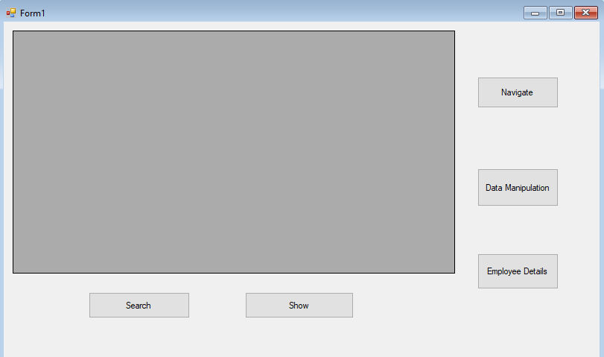

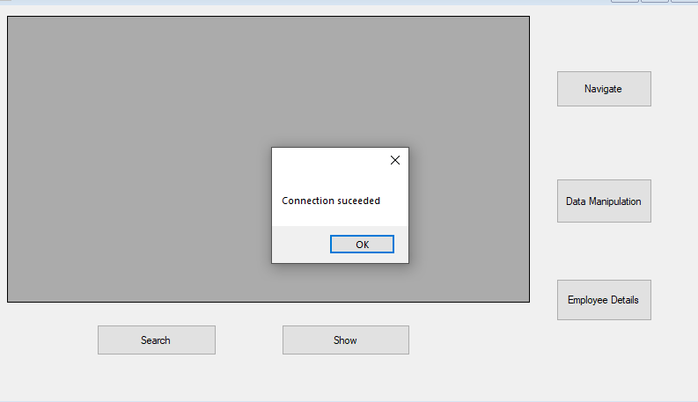

FORM 2 :

using System;

using System.Collections.Generic;

using System.ComponentModel;

using System.Data;

using System.Drawing;

using System.Linq;

using System.Text;

using System.Threading.Tasks;

using System.Windows.Forms;

using System.Data.OleDb;

namespace Lab12_1

{

public partial class Form2 : Form

{

public Form2()

{

InitializeComponent();

}

OleDbConnection con = new OleDbConnection(@"Provider = Microsoft.Jet.OLEDB.4.0; Data Source = C:\SAAD KHAN\Database8.mdb ");

OleDbDataAdapter adap = new OleDbDataAdapter("select* from student", @"Provider = Microsoft.Jet.OLEDB.4.0; Data Source = C:\SAAD KHAN\Database8.mdb ");

DataSet d1 = new DataSet("student");

int counter = 0;

private void Form2_Load(object sender, EventArgs e)

{

con.Open();

adap.Fill(d1,"student");

textBox1.Text = d1.Tables["student"].Rows[0]["StudentID"].ToString();

textBox2.Text = d1.Tables["student"].Rows[0]["stdName"].ToString();

textBox3.Text = d1.Tables["student"].Rows[0]["Phone"].ToString();

textBox4.Text = d1.Tables["student"].Rows[0]["Address"].ToString();

textBox5.Text = d1.Tables["student"].Rows[0]["deptid"].ToString();

}

private void button1_Click(object sender, EventArgs e)

{

if (counter > 0)

{

counter = 0;

textBox1.Text = d1.Tables["student"].Rows[0]["StudentID"].ToString();

textBox2.Text = d1.Tables["student"].Rows[0]["stdName"].ToString();

textBox3.Text = d1.Tables["student"].Rows[0]["Phone"].ToString();

textBox4.Text = d1.Tables["student"].Rows[0]["Address"].ToString();

textBox5.Text = d1.Tables["student"].Rows[0]["deptid"].ToString();

}

else

{

MessageBox.Show("U are already on the first record");

}

}

private void button2_Click(object sender, EventArgs e)

{

if (counter < d1.Tables["student"].Rows.Count - 1)

{

counter = counter + 1;

textBox1.Text = d1.Tables["student"].Rows[counter]["StudentID"].ToString();

textBox2.Text = d1.Tables["student"].Rows[counter]["stdName"].ToString();

textBox3.Text = d1.Tables["student"].Rows[counter]["Phone"].ToString();

textBox4.Text = d1.Tables["student"].Rows[counter]["Address"].ToString();

textBox5.Text = d1.Tables["student"].Rows[counter]["deptid"].ToString();

}

else if(counter <= d1.Tables["student"].Rows.Count - 1)

{

textBox1.Text = d1.Tables["student"].Rows[0]["StudentID"].ToString();

textBox2.Text = d1.Tables["student"].Rows[0]["stdName"].ToString();

textBox3.Text = d1.Tables["student"].Rows[0]["Phone"].ToString();

textBox4.Text = d1.Tables["student"].Rows[0]["Address"].ToString();

textBox5.Text = d1.Tables["student"].Rows[0]["deptid"].ToString();

counter = 0;

}

}

private void button4_Click(object sender, EventArgs e)

{

if (counter > 0)

{

counter = counter - 1;

textBox1.Text = d1.Tables["student"].Rows[counter]["StudentID"].ToString();

textBox2.Text = d1.Tables["student"].Rows[counter]["stdName"].ToString();

textBox3.Text = d1.Tables["student"].Rows[counter]["Phone"].ToString();

textBox4.Text = d1.Tables["student"].Rows[counter]["Address"].ToString();

textBox5.Text = d1.Tables["student"].Rows[counter]["deptid"].ToString();

}

else

{

MessageBox.Show("U are already on the first record");

}

}

private void button3_Click(object sender, EventArgs e)

{

if (counter != d1.Tables["student"].Rows.Count - 1)

{

counter = d1.Tables["student"].Rows.Count - 1;

textBox1.Text = d1.Tables["student"].Rows[counter]["StudentID"].ToString();

textBox2.Text = d1.Tables["student"].Rows[counter]["stdName"].ToString();

textBox3.Text = d1.Tables["student"].Rows[counter]["Phone"].ToString();

textBox4.Text = d1.Tables["student"].Rows[counter]["Address"].ToString();

textBox5.Text = d1.Tables["student"].Rows[counter]["deptid"].ToString();

}

else if(counter >= d1.Tables["student"].Rows.Count - 1)

{

MessageBox.Show("ALready on Last record");

}

}

private void button5_Click(object sender, EventArgs e)

{

Form1 f1 = new Form1();

f1.Show();

}

}

}

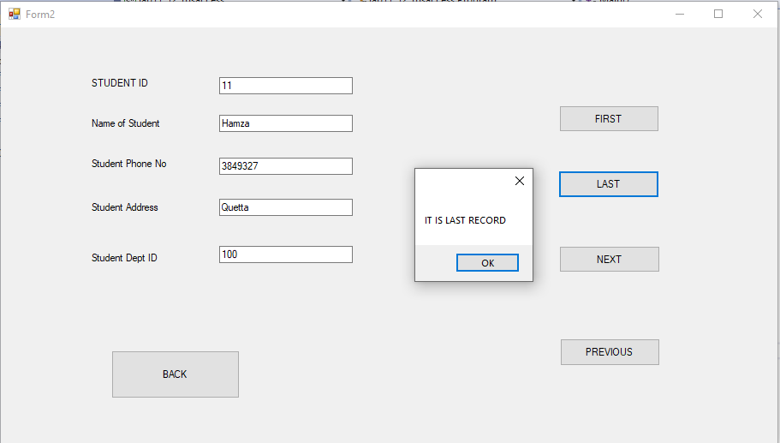

FORM 3 :

using System;

using System.Collections.Generic;

using System.ComponentModel;

using System.Data;

using System.Drawing;

using System.Linq;

using System.Text;

using System.Threading.Tasks;

using System.Windows.Forms;

using System.Data.OleDb;

namespace Lab12_1

{

public partial class Form3 : Form

{

public Form3()

{

InitializeComponent();

}

OleDbConnection con = new OleDbConnection(@"Provider = Microsoft.Jet.OLEDB.4.0; Data Source = C:\SAAD KHAN\Database9.mdb");

OleDbDataAdapter adap = new OleDbDataAdapter("select* from student", @"Provider = Microsoft.Jet.OLEDB.4.0; Data Source = C:\SAAD KHAN\Database9.mdb ");

DataSet d1 = new DataSet("student");

private void Form3_Load(object sender, EventArgs e)

{

con.Open();

adap.Fill(d1, "student");

textBox1.Text = d1.Tables["student"].Rows[0]["StudentID"].ToString();

textBox2.Text = d1.Tables["student"].Rows[0]["stdName"].ToString();

textBox3.Text = d1.Tables["student"].Rows[0]["Phone"].ToString();

textBox4.Text = d1.Tables["student"].Rows[0]["Address"].ToString();

textBox5.Text = d1.Tables["student"].Rows[0]["deptid"].ToString();

con.Close();

}

private void button1_Click(object sender, EventArgs e)

{

con.Open();

OleDbCommand com = new OleDbCommand("Update student set Address = '" + textBox4.Text + "' where stdName = '"+textBox2.Text+"'", con);

com.ExecuteNonQuery();

MessageBox.Show("THE RECORD HAS BEEN UPDATED");

con.Close();

}

private void button3_Click(object sender, EventArgs e)

{

con.Open();

OleDbCommand com2 = new OleDbCommand("delete from student where StudentID = " + textBox1.Text + "", con);

com2.ExecuteNonQuery();

MessageBox.Show("THE RECORD HAS BEEN DELETED");

con.Close();

}

private void button2_Click(object sender, EventArgs e)

{

con.Open();

OleDbCommand com1 = new OleDbCommand("Insert into student(StudentID, stdName, Phone, Address, deptid) values('" + textBox1.Text + "','" + textBox2.Text + "','" + textBox3.Text + "','" + textBox4.Text + "','" + textBox5.Text + "')", con);

com1.ExecuteNonQuery();

MessageBox.Show("THE RECORD HAS BEEN ADDED");

con.Close();

}

private void button4_Click(object sender, EventArgs e)

{

textBox1.Text = "";

textBox2.Text = "";

textBox3.Text = "";

textBox4.Text = "";

textBox5.Text = "";

}

private void button5_Click(object sender, EventArgs e)

{

this.Hide();

}

}

}

FORM 4 :

using System;

using System.Collections.Generic;

using System.ComponentModel;

using System.Data;

using System.Drawing;

using System.Linq;

using System.Text;

using System.Threading.Tasks;

using System.Windows.Forms;

using System.Data.OleDb;

namespace Lab12_1

{

public partial class Form4 : Form

{

public Form4()

{

InitializeComponent();

}

OleDbConnection con = new OleDbConnection(@"Provider = Microsoft.Jet.OLEDB.4.0; Data Source = C:\SAAD KHAN\Database7.mdb");

OleDbDataAdapter adap = new OleDbDataAdapter("select* from student", @"Provider = Microsoft.Jet.OLEDB.4.0; Data Source = C:\SAAD KHAN\Database9.mdb ");

DataSet d1 = new DataSet("student");

private void Form4_Load(object sender, EventArgs e)

{

con.Open();

comboBox1.DropDownStyle = ComboBoxStyle.DropDownList;

OleDbCommand com = new OleDbCommand("select stdName from student", con);

OleDbDataReader d1 = com.ExecuteReader();

while (d1.Read())

{

string b = d1["stdName"].ToString();

comboBox1.Items.Add(b);

}

}

private void button2_Click(object sender, EventArgs e)

{

dataGrid1.DataSource = null;

}

private void button1_Click(object sender, EventArgs e)

{

string b = comboBox1.Items[comboBox1.SelectedIndex].ToString();

OleDbDataAdapter adap = new OleDbDataAdapter("select student.stdName,Courses.CourseName from Courses inner join student on Courses.Cid=student.Cid where stdName='" + b + "'", con);

DataTable d2 = new DataTable("Courses");

adap.Fill(d2);

dataGrid1.DataSource = d2;

}

private void button3_Click(object sender, EventArgs e)

{

this.Hide();

}

}

}

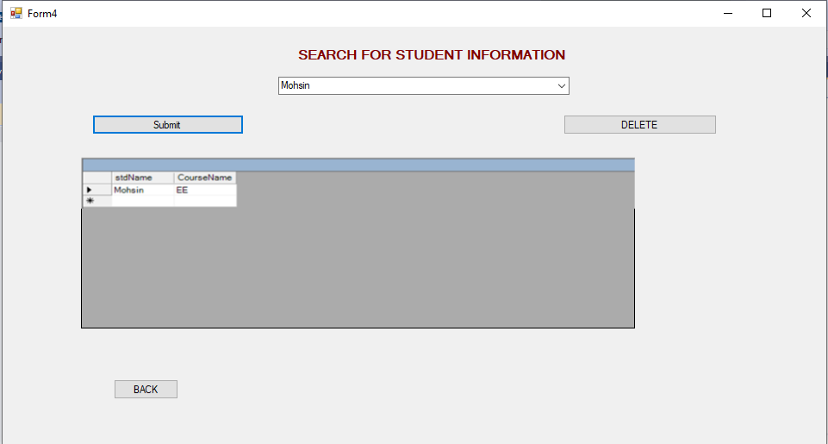

FORM 5 :

using System;

using System.Collections.Generic;

using System.ComponentModel;

using System.Data;

using System.Drawing;

using System.Linq;

using System.Text;

using System.Threading.Tasks;

using System.Windows.Forms;

using System.Data.OleDb;

namespace Lab12_1

{

public partial class Form5 : Form

{

public Form5()

{

InitializeComponent();

}

OleDbConnection con = new OleDbConnection(@"Provider = Microsoft.Jet.OLEDB.4.0; Data Source = C:\Users\AK Systems\Documents\Database1.mdb");

OleDbDataAdapter adap = new OleDbDataAdapter("select* from student", @"Provider = Microsoft.Jet.OLEDB.4.0; Data Source = C:\SAAD KHAN\Database10.mdb ");

DataSet d1 = new DataSet("student");

private void Form5_Load(object sender, EventArgs e)

{

con.Open();

comboBox1.DropDownStyle = ComboBoxStyle.DropDownList;

OleDbCommand com = new OleDbCommand("select ename from emp", con);

OleDbDataReader d1 = com.ExecuteReader();

while (d1.Read())

{

string b = d1["ename"].ToString();

comboBox1.Items.Add(b);

}

}

private void comboBox1_SelectedIndexChanged(object sender, EventArgs e)

{

string c = comboBox1.Items[comboBox1.SelectedIndex].ToString();

OleDbDataAdapter adap = new OleDbDataAdapter("select emp.ename,Courses.CourseName from Courses inner join emp on Courses.empno=emp.empno where ename='" + c + "'", con);

DataTable d2 = new DataTable("Courses");

adap.Fill(d2);

dataGrid1.DataSource = d2;

}

private void button1_Click(object sender, EventArgs e)

{

this.Hide();

}

}

}

